**Downloading your Video Game Sales Data**

The data referred to below was motivated by Gregory Smith's web scrape of VGChartz [Video Games Sales](https://www.kaggle.com/gregorut/datasets). The data set extends the number of variables with another web scrape from [Metacritic](http://www.metacritic.com/browse/games/release-date/available). Please note that the data does not include all original observations. The fields include: Name, Platform, Year_of_Release, Genre, Publisher, NA_Sales, EU_Sales, JP_Sales, Other_Sales, Global_Sales, Critic_Score, Critic_Count, User_Score, User_Count, Developer and Rating.

**Step 1 (Registering with Kaggle):**

Begin by registering for free with Kaggle to begin your free download. The registration page can be accessed by clicking the link below. (Should you already have a free profile with Kaggle please proceed directly to step 2).

<https://www.kaggle.com/account/login?phase=startRegisterTab&returnUrl=%2F>

**Step 2 (Data Download):**

Begin by clicking on the hyperlink below to bring you to the Video Game Sales data.

<https://www.kaggle.com/rush4ratio/video-game-sales-with-ratings>

You will see a screen similar to below. Navigate to the far-right hand side of the page and click on the download button and select CSV (See below circled in red).

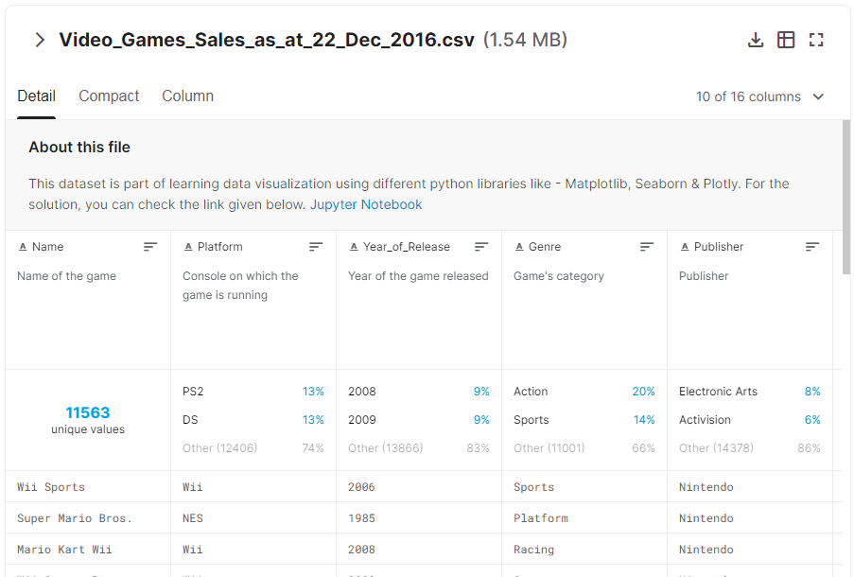

Once your data has been downloaded please save it to your computer where you can access at anytime.

**Sources**

Kaggle- Video Game Sales with Ratings. Retrieved November 11, 2020 from: https://www.kaggle.com/rush4ratio/video-game-sales-with-ratings